The Human Experience

of COVID-19 Lockdowns:

The Rise of Pandemic Hobbies

Emily Linebarger

## 

## Introduction

For my final project, I wanted to explore how COVID-19 lockdowns influenced so-called “pandemic hobbies”. The COVID-19 pandemic disrupted daily routines nearly everywhere in the world, and in the United States I have heard anecdotal evidence that bread-baking, gardening, and taking care of a new pet rose in popularity. I wanted to explore how strong the correlation was between COVID-19 cases and these pandemic hobbies, and if the pandemic represented a statistically abnormal growth in related economic sectors. With this analysis, I am hoping to connect a human story of how lockdown felt to a datafied time series of cases.

## Background/Related Work

I was assigned Franklin County, Ohio for the assignment 4 common analysis. Figure 1 shows the graph of the daily infection rate as well as its change over time. The sections with orange bars indicate time periods where a mask mandate was in place.

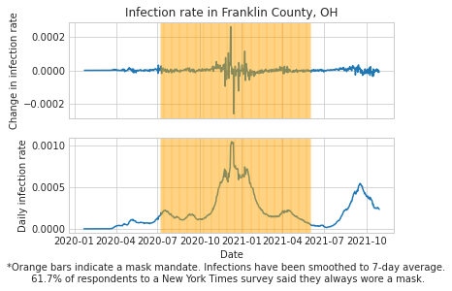

*Figure 1: Infection rate in Franklin County, OH (turned in for Assignment 4)*

For assignments A5 - A7, I wanted to take a different approach that grounded this datafied series of cases in the human experience of the first year of the pandemic. The inspiration for this project came from many news stories over the past year about activities people were trying in lockdown. This is a small subset of these such articles:

* [People are showing off unexpected hobbies they picked up during quarantine, and they are exceedingly delightful (Buzzfeed)](https://www.buzzfeed.com/michelleno/most-popular-pandemic-hobbies)
* [Pandemic hobbies: More than just baking bread (Buffalo News)](https://buffalonews.com/news/local/pandemic-hobbies-more-than-just-baking-bread/article_a725f6ce-4144-11eb-b4d1-e3fdf7520df5.html)
* [Pandemic bakers are going pro (New York Times)](https://www.nytimes.com/2021/06/12/business/pandemic-baking-career.html)
* [Coronavirus pandemic leads to new generation of plant, garden lovers (ABC 7)](https://abc7chicago.com/gardening-for-beginners-hobby-planting/6313625/)
* [Gardening grows as a chosen pandemic hobby (India Ahead News)](https://www.youtube.com/watch?v=uJj9KBFcBiE)
* [Vegetable growing and backyard chickens: Gardening, farming booms during coronavirus pandemic (USA Today)](https://www.usatoday.com/story/money/2020/04/14/coronavirus-gardening-hobby-and-self-sustainability-create-interest/2923047001/)
* [Pet adoption soared during the pandemic. But now, shelters report overcrowding (NPR)](https://www.npr.org/2021/06/06/1003713898/pet-adoption-soared-during-the-pandemic-but-now-shelters-report-overcrowding)
* [Did the COVID-19 pandemic spark a public interest in pet adoption? (Frontiers in Veterinary Science)](https://www.frontiersin.org/articles/10.3389/fvets.2021.647308/full)
* [Cats big winners in Seattle pandemic pet-adoption surge (Seattle Times)](https://www.seattletimes.com/seattle-news/data/cats-big-winners-in-seattle-pandemic-pet-adoption-surge/)

From my personal experience, I knew that many of my friends had talked about trying bread baking, gardening, and/or had thought about adopting a pet during lockdown. So I wanted to see whether the trend in COVID-19 cases was a good predictor of growth in economic sectors related to these hobbies.

## Methodology

I hope to examine how economic indicators related to pandemic hobbies correlate with overall US cases and deaths. I am interested primarily in correlation statistics during 2020 (for datasets where month-by-month data is available) as well as whether COVID-19 caused abnormal growth in these indicators beyond projected trends. So, my two primary analyses for each pandemic hobby will be:

1. Reviewing the covariance between US COVID-19 cases and pandemic hobby indicators, for datasets where granular date information is available.
2. Where less granular data is available, exploring the relationships between cases and pandemic hobbies through a series of graphs, to draw more qualitative conclusions about the experience of early-2020 lockdowns.

## Discussion of Findings

### Bread Baking

When searching for data sets, I was hoping to find economic data for a single product, like bread flour or yeast. Several news stories suggested those had been in scarce supply[1][2][3][4], and I would expect to see clear price spikes for these products. However, I was not able to find data at this level of granularity. Instead, I found aggregate consumer price datasets from the US Department of Agriculture.

The available consumer price index categories in this dataset were:

* All food
* Food away from home
* Food at home
* Meats, poultry and fish
* Meats
* Beef and veal
* Pork
* Other meats
* Poultry
* Fish and seafood
* Eggs
* Dairy products
* Fats and oils
* Fruits and vegetables
* Fresh fruits and vegetables
* Fresh fruits
* Fresh vegetables
* Processed fruits and vegetables
* Sugar and sweets
* Cereals and bakery products
* Nonalcoholic beverages
* Other foods

From this list, I selected “Eggs”, “Dairy products”, and “Cereals and bakery products” as a proxy for home baking goods. For certain analyses, I dropped the aggregate categories “All food”, “Food away from home”, “Food at home”, “Meats, poultry and fish”, and “Fruits and vegetables”.

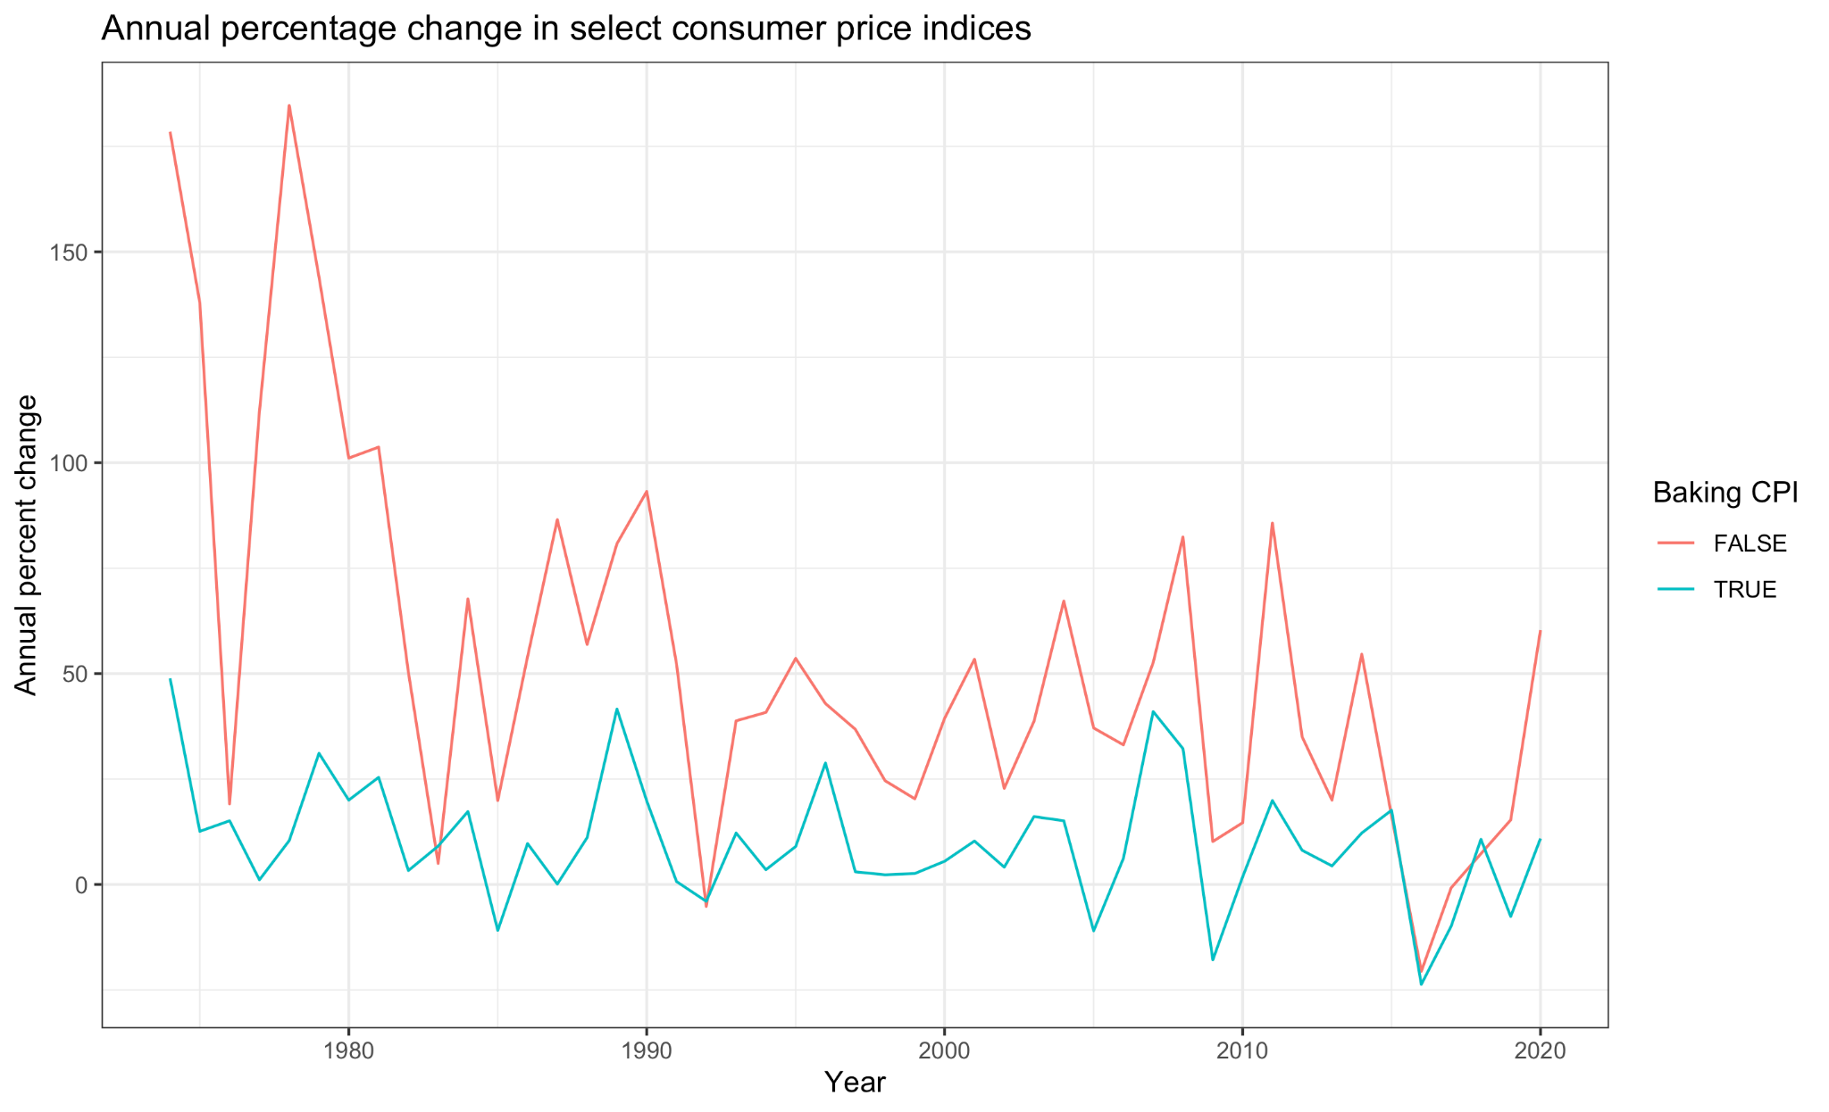

*Figure 2: Annual percentage change in select consumer price indices*

Figure 2 shows the percentage change in these agricultural price indices from 1974 - 2020. I grouped all non-aggregate, non-baking categories together and compared them to my selected baking categories. It is important to note that these data are not in an ideal format for aggregating - the raw data are available as percentage points either increased or decreased from the previous year’s index. However, this graph can give a rough idea of how the trends have changed.

The first trend that jumps out is there is a lot of variation in both lines. If I showed each index on this chart, the graph would be busier still. Financial shocks are a regular occurrence, and agricultural markets are volatile. Therefore, even though the COVID-19 pandemic was a historical event, it may present in financial data as a somewhat-average price shock.

The second finding that I see is that both categories did show price increases from 2019 - 2020, but the baking category increased slightly more.

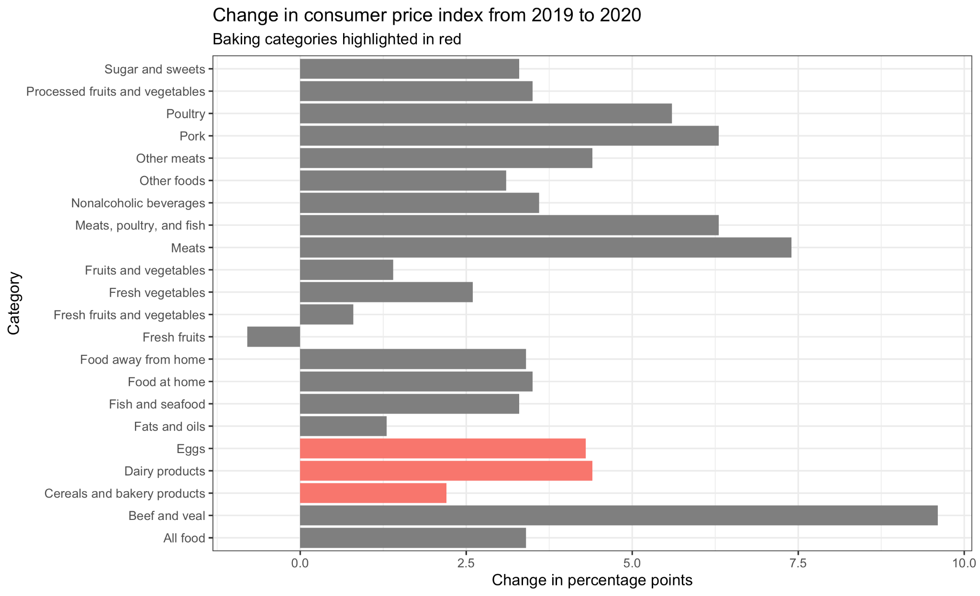

*Figure 3: Percentage point change in CPI from 2019-2020, by category*

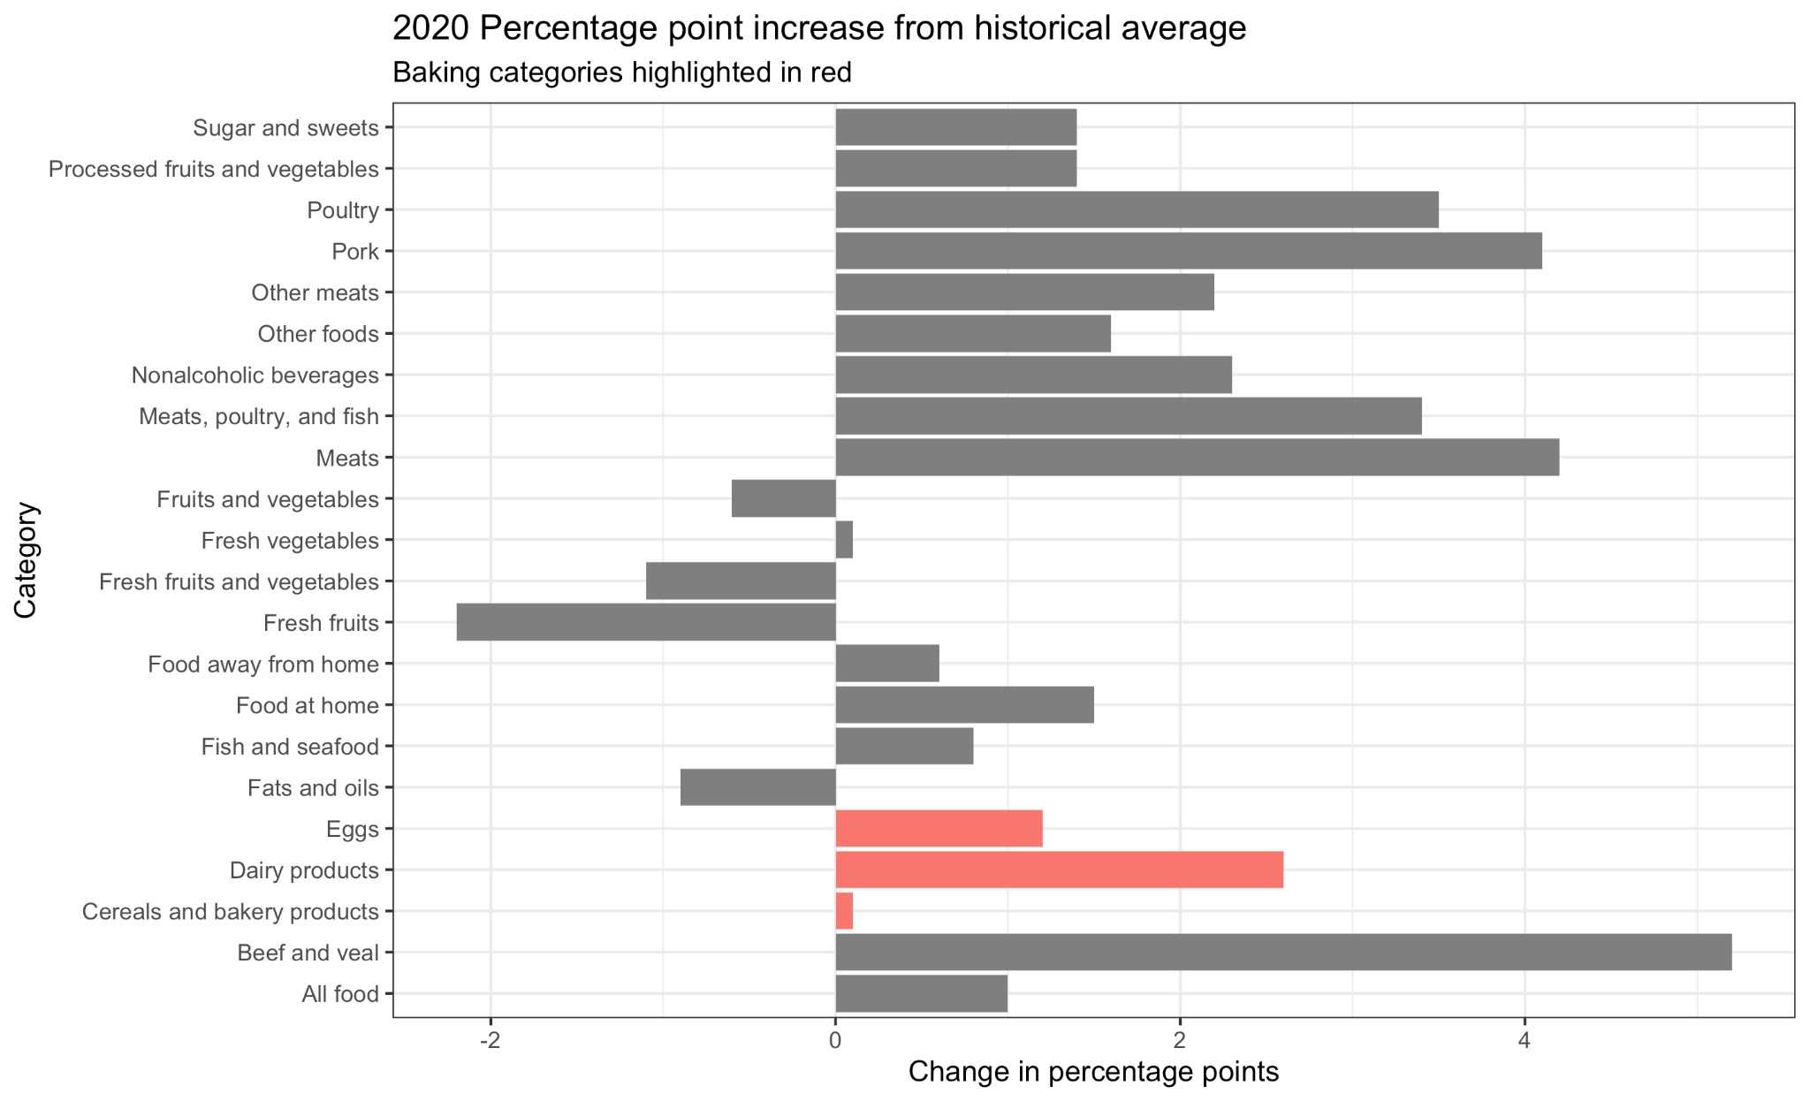

*Figure 4: Percentage point change in 2020 compared to historical average*

These datasets were not granular enough to show a significant rise in economic activity related to bread baking. However, there is too much qualitative data to ignore this trend, so this argument needs more granular data to support it.

### Gardening

For gardening, I was able to get much more granular data than for bread baking. The US Federal Reserve publishes a monthly dataset of advance retail sales for building materials/garden supply stores. Figure 5 shows a time series of this data from 1992 - 2021.

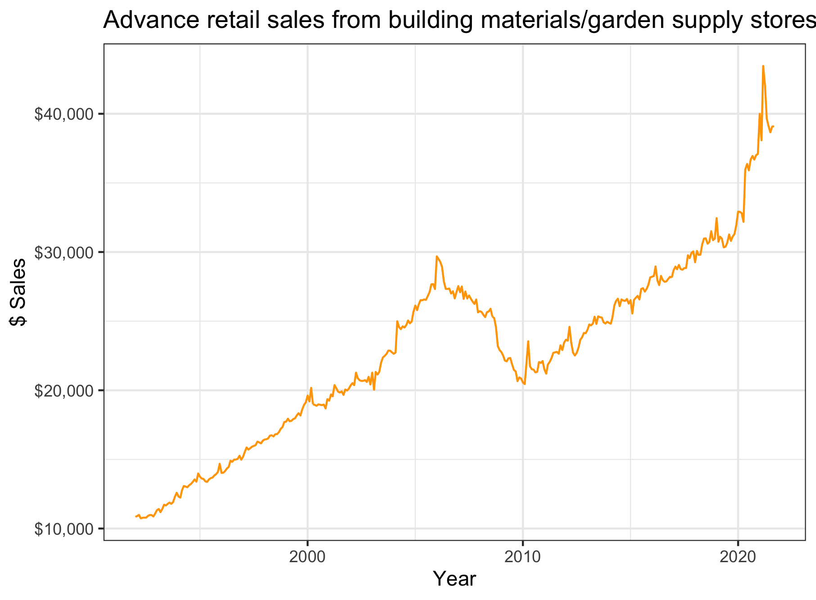

*Figure 5: Advance garden retail sales 1992-2021*

It was difficult to see trends during COVID-19 on this graph, so I created figure 6 to show just 2019 - 2021. These data were available through September 2021.

The first trend that jumps out to me here is the sharp spike in sales during Q2 of 2020. During a time when recession concerns were high[5][6], it seems that there was a sharp increase in garden/home supply sales.

The second thing I notice is that there is a similar jump in sales for the first half of 2021. This could be another pandemic spike (perhaps at the end of the winter surge caused by the Delta variant), but I was concerned this was due to seasonality. Perhaps home and garden retailers had a normal buying spree at the start of the year to prepare for the spring/summer gardening season.

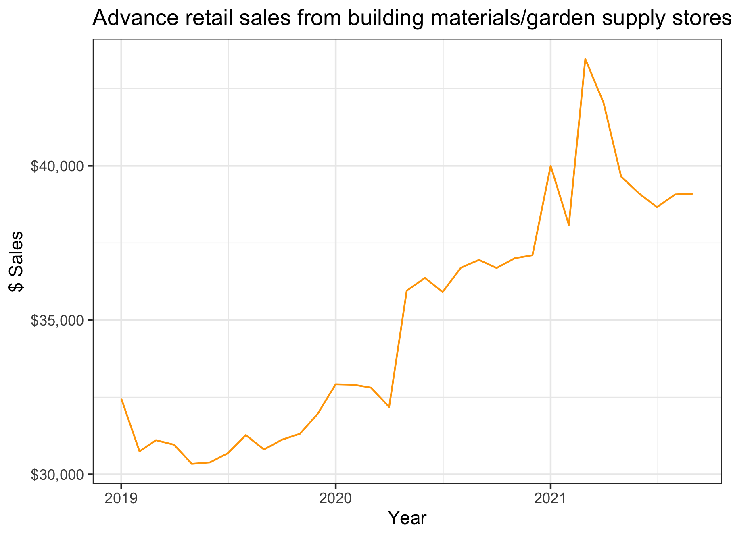

*Figure 6: Advance garden retail sales 2019 - 2021*

To rule out seasonality as a driving factor I could create an annually-smoothed time series using the data since 1974, and overlay it with COVID-19 cases. However, this might lose some of the important signal from the 24 months of pandemic data we have access to. This analysis could benefit from more advanced statistical methods.

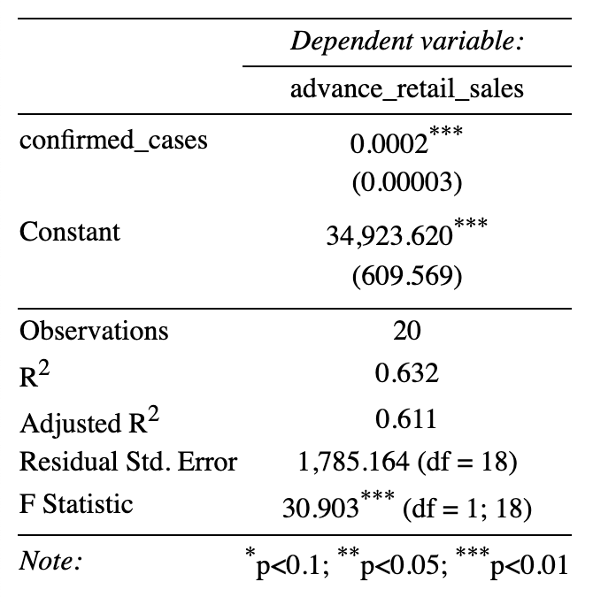

*Figure 7: Linear relationship between COVID-19 cases and advance home/garden retail sales*

Finally, because I had such granular data, I could look at the covariance between COVID-19 cases and advance garden sales in the United States. Figure 7 shows the results of this regression[7]. My p-value was 0.0002, which suggests a highly linear relationship during the time period studied.

### Pet Adoptions

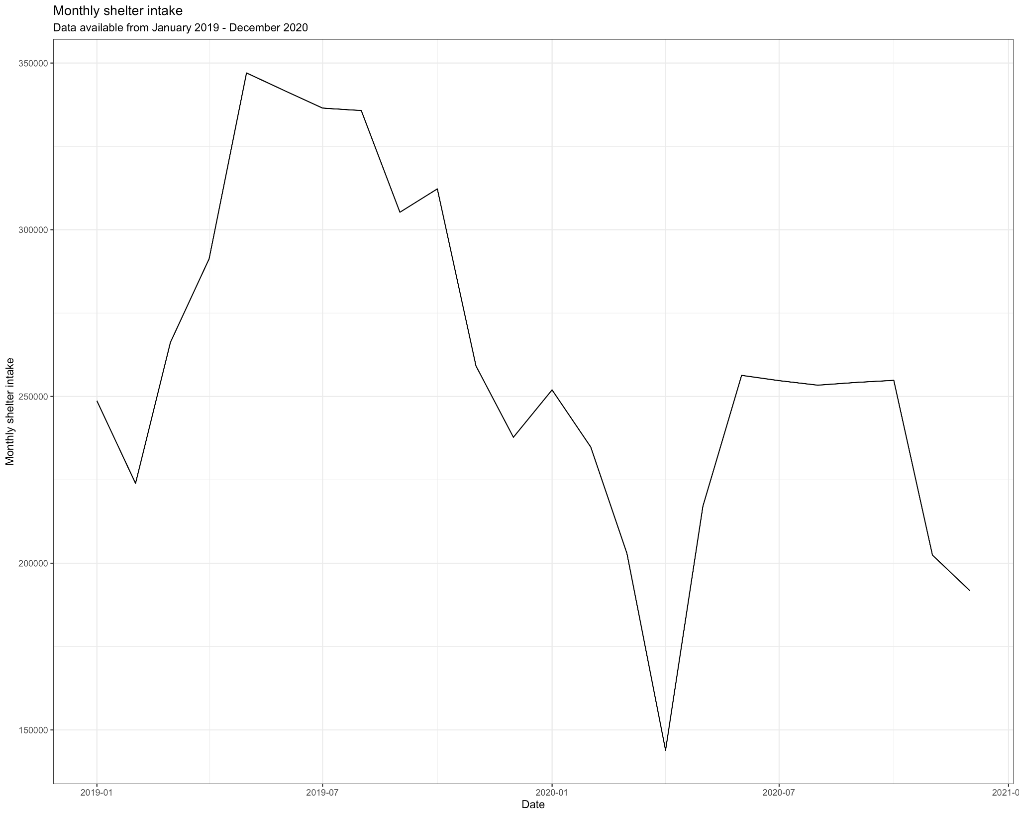

*Figure 8: Time series of shelter intake, 2019-2021*

For pet adoption, I found a dataset from a national nonprofit called Shelter Animals Count. They have a publicly available COVID-19 data dashboard[8] which shows how certain statistics on pet adoption changed over the pandemic.

Figure 8 shows the time series of monthly shelter intake, which has a noticeable drop in the first months of 2020. This gives credence to the articles reporting a sharp rise in dog and pet adoptions at the start of COVID-19 lockdowns. However, shelter intake rises again and then plateaus in the fall and winter of 2020. My theory here is that American households only had so many pets they could adopt out of the shelter system, and then once that “reserve” was exhausted, shelter intake crept back up again.

I also ran a simple OLS regression of COVID-19 cases on monthly shelter intake, and obtained the results in figure 9. This relationship was not statistically significant with a p-value of 0.998. However, this relationship was not linear for all of 2020, as there was a rebound in shelter intake during the second half of the year. Another way to approach this would be a time-lagged correlation for the first six months of 2020.

## 

*Figure 9: Linear relationship between COVID-19 cases and monthly shelter intake*

## Limitations

I am limited by the variables and dimensions available in these datasets, which seem to cover only the US in aggregate. I expect that some economic measures will have changed definition over time, and so I may have a difficult time isolating certain sectors (as a hypothetical, perhaps building and garden supply stores were simply hardware stores sometime in the past). Some of the datasets are available on different time scales, and very few seem to be disaggregated at the county level.

## Conclusion

It is difficult to draw conclusions from these datasets without more data. There is overwhelming qualitative evidence that the popularity of certain activities rose in pandemic-imposed lockdowns, but the publicly available data is sometimes not granular enough to show these trends. I saw that for the two hobbies with monthly time series data available (gardening and pet adoption), there was a notable change in activity during the first months of 2020. For gardening in particular, COVID-19 cases were a strong indicator of home and garden sales, with a p-value of 0.0002. For bread baking I was not able to find a dataset with granular time series data, so this analysis would benefit from future, more granular analyses.

## Data Sources

Some datasets may be relevant for more than one hobby. Specifically, some of the retail sector datasets may have multiple relevant data points.

COVID-19 cases

* **Johns Hopkins University:** COVID-19 cases and deaths (<https://www.kaggle.com/antgoldbloom/covid19-data-from-john-hopkins-university?select=RAW_us_confirmed_cases.csv>)

Bread baking:

* **US Department of Agriculture Food Price Outlook:** Contains food price index data from 1974 - 2020. (<https://www.ers.usda.gov/data-products/food-price-outlook/>)
* **US Census Bureau, Monthly Retail Trade Report** There are several datasets here, but I’m most interested in the “Retail and Food Services Sales” and “Retail Industries” datasets. These provide economic survey data for retailers in the United States from 1992-present. (<https://www.census.gov/retail/index.html>)

Gardening:

* **St. Louis Federal Reserve, Retail Sales for building materials and garden supply retailers** This is a monthly dataset available from 1992 - 2021. (<https://fred.stlouisfed.org/series/RSBMGESD>)

Pet Adoption:

* **Shelter Animals Count, COVID-19 Statistics** This organization attempts to be a national source of data on shelter animals. They have a public dataset available about COVID-19 (2019 - 2020), as well as selected data available from 2016-2018. (<https://www.shelteranimalscount.org/COVID-19>)

1. https://www.theatlantic.com/health/archive/2020/05/why-theres-no-flour-during-coronavirus/611527/
2. https://www.bloomberg.com/news/features/2020-06-16/how-king-arthur-dealt-with-a-flour-shortage-during-the-pandemic
3. https://thecounter.org/covid-19-coronavirus-flour-shortage-supply-regional-grain/
4. https://time.com/5836012/flour-shortage-history/
5. https://www.nytimes.com/2020/10/03/upshot/pandemic-economy-recession.html
6. https://www.cnbc.com/2020/01/02/ceos-still-consider-recession-to-be-the-biggest-business-risk-in-2020.html
7. My formula was lm(advance_retail_sales ~ confirmed_cases).
8. https://www.shelteranimalscount.org/COVID-19